CSA-07

Lab Experiments 21-24

21. IoT based smart home applications. 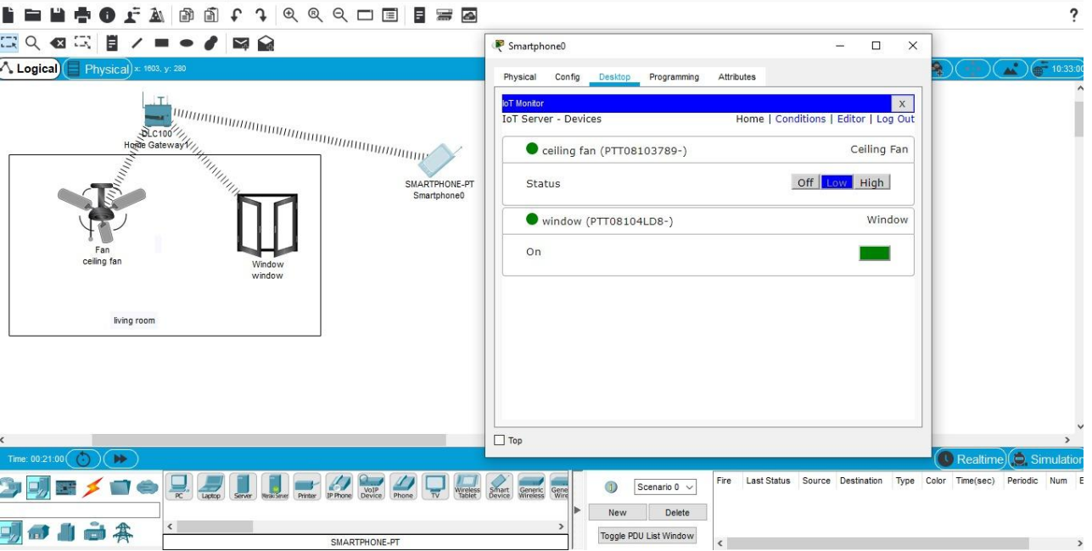  
  
22. Implementation of IoT based smart gardening.

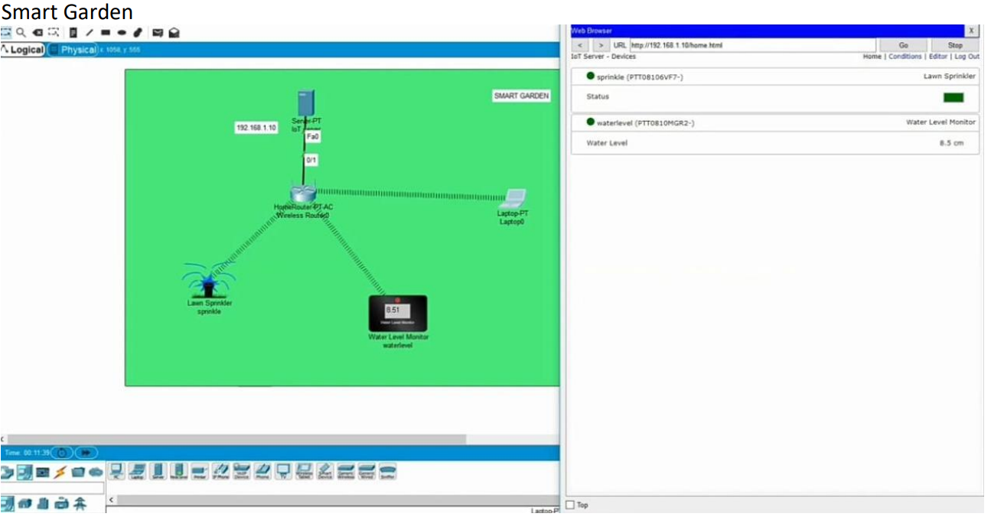  
  
23. Implementation of IoT devices in networking. 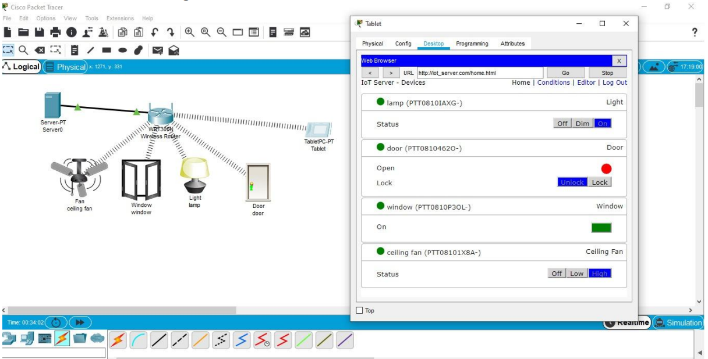  
  
24. IOT Based Smart building using WPA Security & Radius Server. 